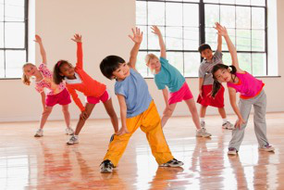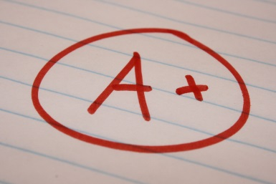

***What’s the problem?***

**and advocate for my child’s health and physical education**

**Parents can use Missouri Association for Health, Physical Education, Recreation and Dance (MOAHPERD) as a tool. They have resources to help you speak up for health and physical education. Actions to take through MOAHPERD are:**

* **Attend a MOAHPERD meeting**
* **Present Advocacy PowerPoint to school board or PTA**
* **Join the Missouri Coordinated School Health Coalition**
* **Be a part of the Quality Health & Physical Education Project**
* **Fundraise for the program Physical Best**

**These resources can be found on moahperd.org**

***How do parents speak up?***

***Why do parents need to speak up?***

**I’m Ready to Speak Up**

**Health and physical education improve your child’s quality of life.**

* **Increases school attendance**
* **Improves grades**
* **Creates future healthy lifestyles**
* **31.7% of all children ages 2- 19 are overweight**
* **Only 33.1% of Missouri children go to daily P.E. class**
* **Only 7.5% of K-5 schools meet the required hours for health education**